Niel H. McElroy
1904-1972
Niel McElroy began to work for Proctor & Gamble in 1926, becoming the company's president in 1948. His seminal contribution was the development of the idea of "brand management" in 1931.
McElroy was working on advertising for the company's new perfumed soap, Camay, and was concerned with how to deal with the competition from P&G's Ivory soap. His idea was that each brand should be managed as a separate business. The natural differentiation of the brands meant they were targeted at different
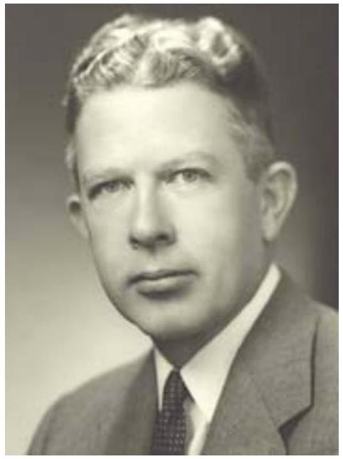
customers, or at least different uses, so that each should concentrate on its own success. McElroy's genius was not only in seeing the economics of brand management, but in designing an organizational structure and specialized roles to carry it out.
In 1957, President Eisenhower tapped McElroy to be the U.S. Secretary of Defense.
From American Business, 1920-2000: How It Worked, by Thomas K. McCraw:
Neil McElroy's formula for P&G's success was: "Find out what the consumers want and give it to them." Proctor & Gamble went to extreme lengths to do both. It hired hundreds of women to bake, wash dishes, and do laundry in their own homes, and then report the results. This kind of market research became the hallmark of P&G's approach to the development of new products and the continuous effort to improve existing ones.
For many years, the leader of the market-research effort was D. Paul Doc" Smelser. He started at P&G in a new unit that had been organized in 1923 for the purpose of analyzing the markets for cottonseed oil and other commodities. Doc was fond of walking up to senior executives and asking them, out of the blue, questions such as "What percentage of Ivory soap is used for face and hands and what percentage for dishwashing?" Often nobody knew the answer. Thus Smelser was able to conclude that P&G, as a company, remained ignorant of some basic elements of how its products were being used, and therefore how they should be marketed.
In P&G created a formal Market Research Department and put Doc himself in charge of it. For the next 34 years, until his retirement in 1959, Doc built this group into perhaps the most sophisticated unit of its kind in the world. He and his staff of researchers (ultimately several hundred strong) asked a variety of audiences a series of detailed questions.
One of Doc's best-known innovations was Procter & Gamble's corps of door-to-door interviewers. This group consisted mostly of young women who had graduated from college and therefore possessed "the maturity to travel alone," as one of their supervisors put it. A criterion for the successful applicant was that she be attractive but not inordinately so. Doc wanted members of his force to project a wholesome and nonthreatening image, so as to inspire confidence and elicit candid answers.
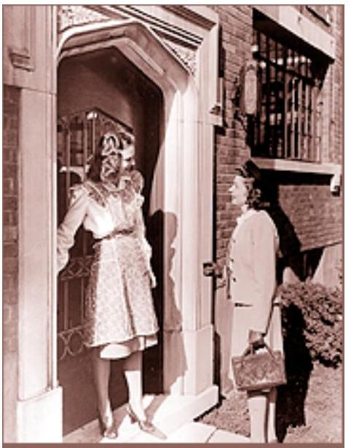
One of Doc Smelser's 3000
door-to-door interviewers, calling on a consumer as part of P&G's
ceaseless market research, 1940s.
Courtesy of The Proctor & Gamble Company.
Doc's interviewers infiltrated neighborhoods all over the country, going from house to house armed with an imposing array of questions: about laundry, cooking, dishwashing, and every other activity for which P&G marketed a product or was thinking of introducing one. Female interviewers were instructed to wear a conservative dress, high heels, gloves, and a hat. As they knocked on doors and talked with consumers, they were to carry no lists, forms, or writing materials. The visits could then seem more casual, even though all conversations were designed to extract copious and specific data. Interviewers were expected to have total recall, and often would hurry back to their cars to record what they had learned. During Doc's 34 years with P&G, a total of 3,000 women and a fair number of men worked as field researchers.

